USE DASHBOARD NODES FOR CREATING UI (WEB APP)

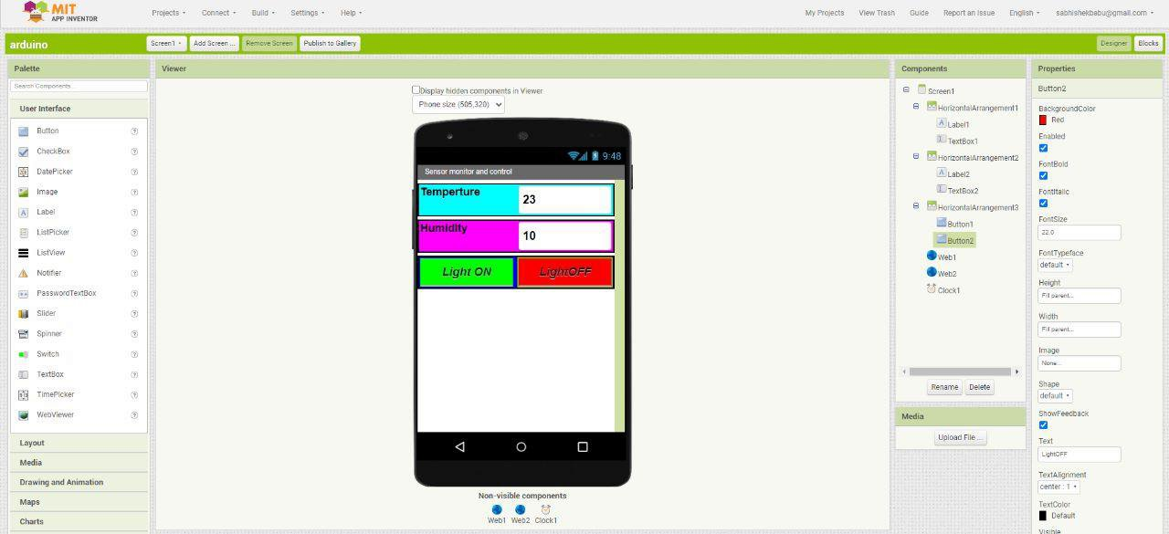
Ui Nodes Installation:
Date | 15 November 2022
Team ID | PNT2022TMID44492
Project Name | Project - Signs with smart connectivity for Better road safety
Maximum Marks | 4 Marks

